Feedback from Finance Webinar with Paul de Wet (July 24)
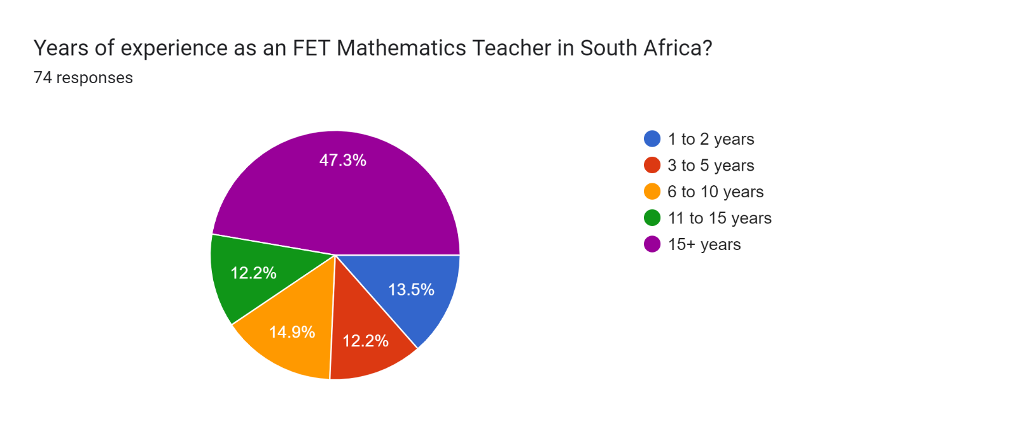
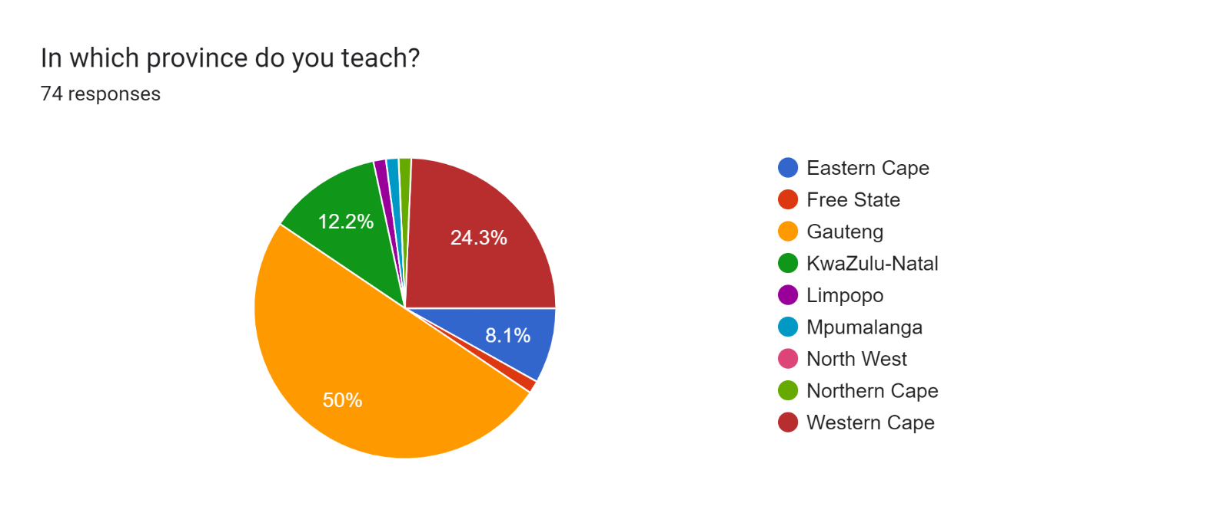

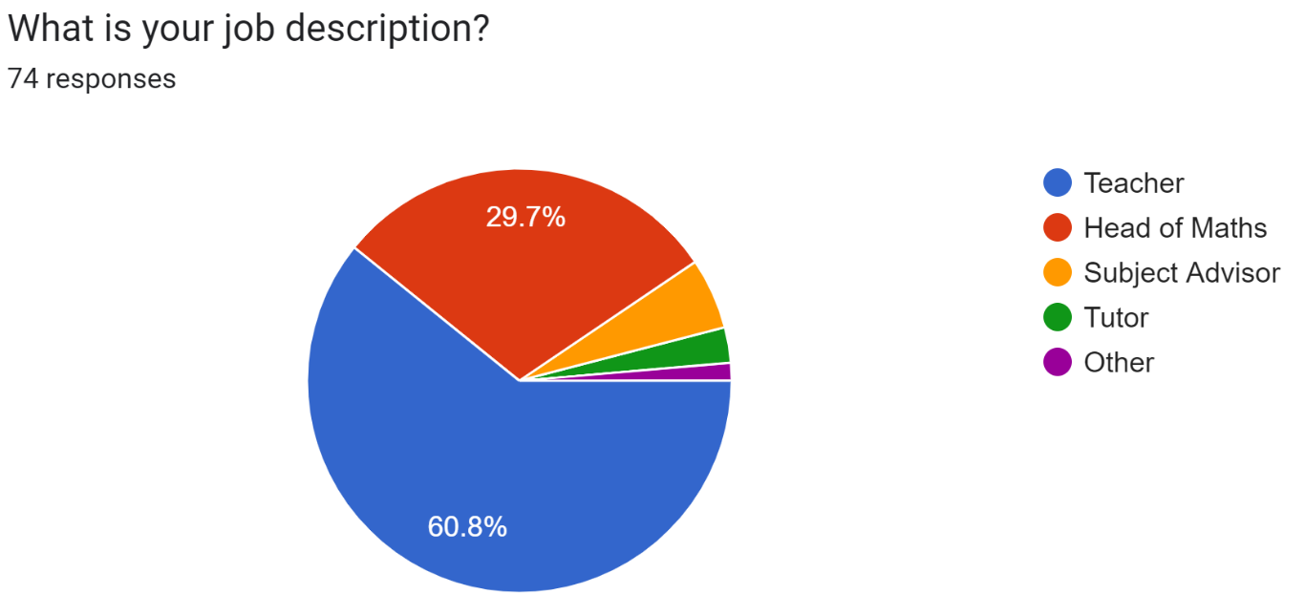

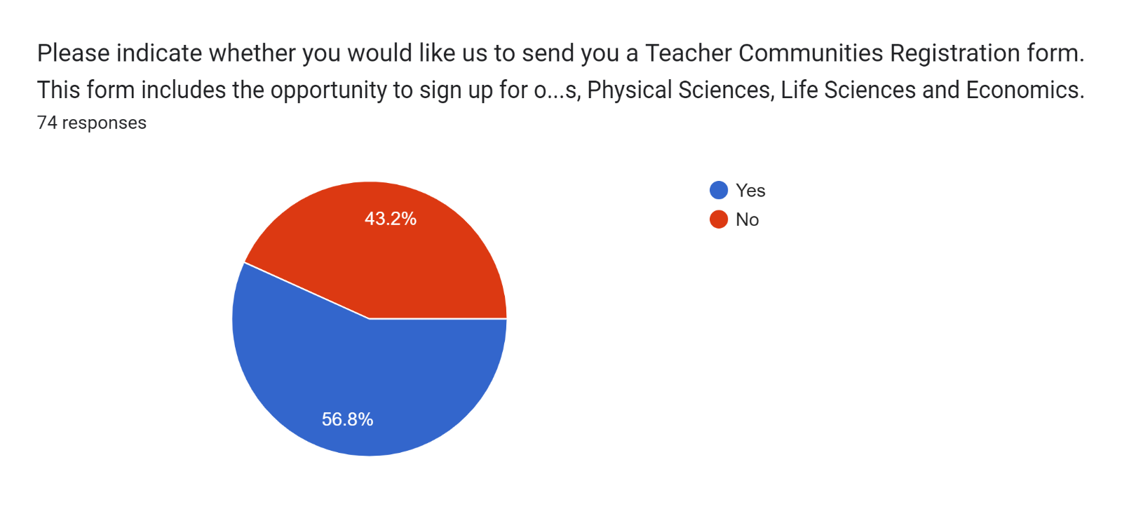
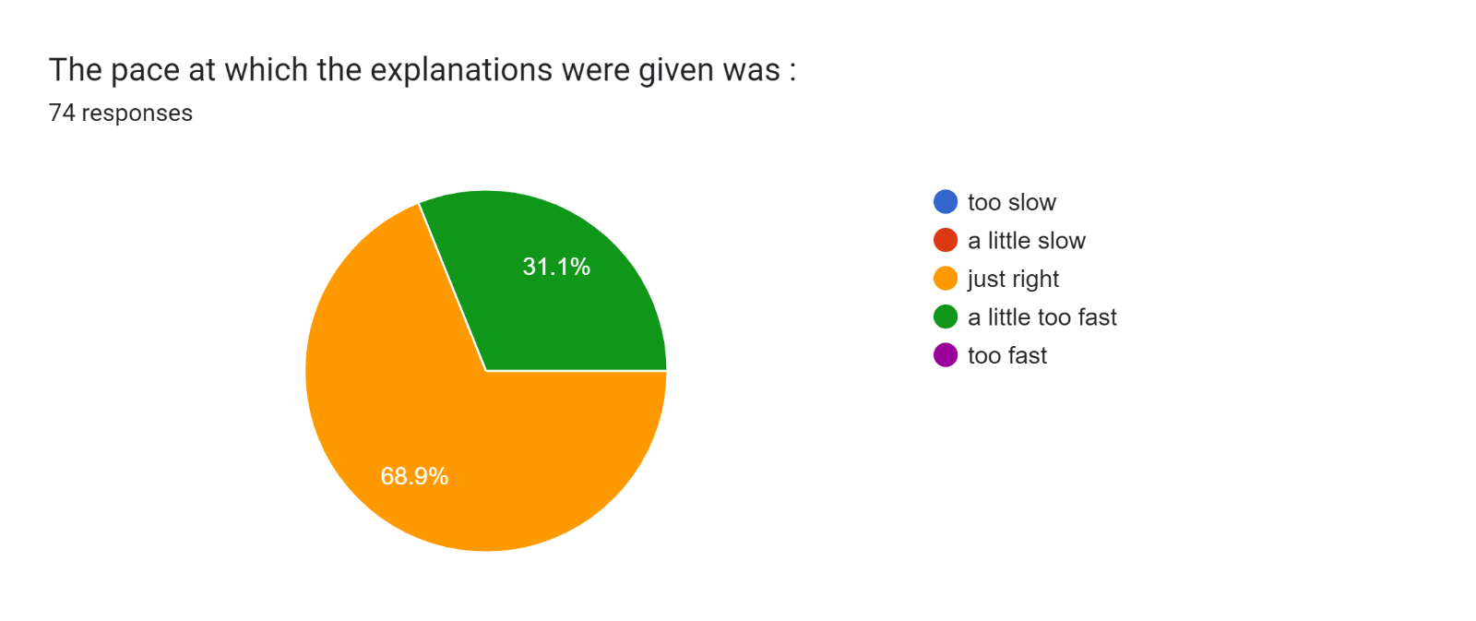

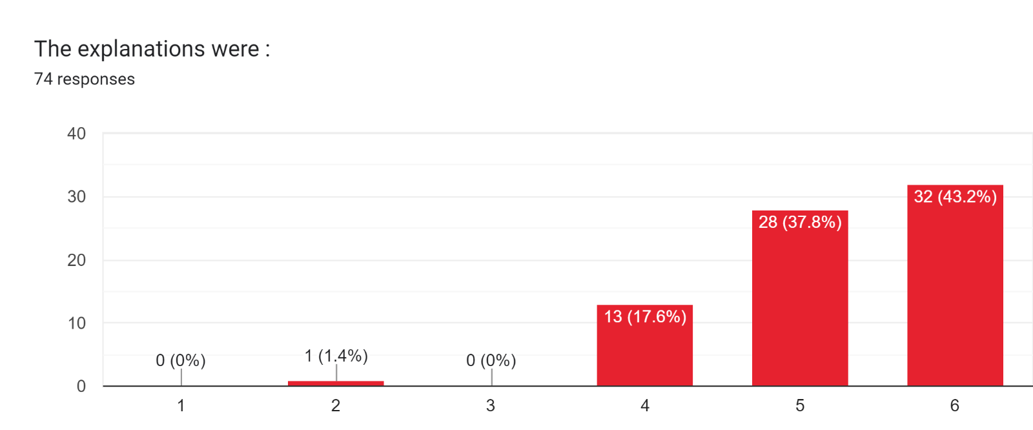
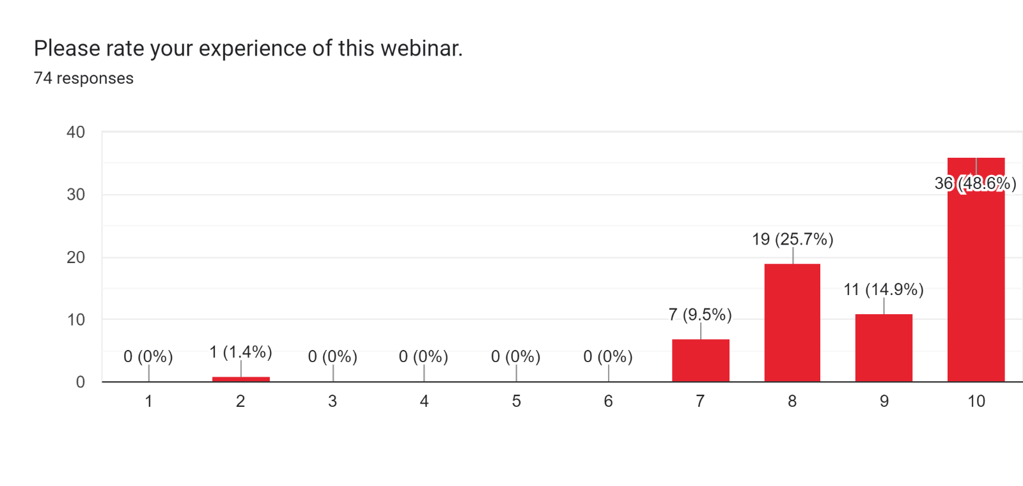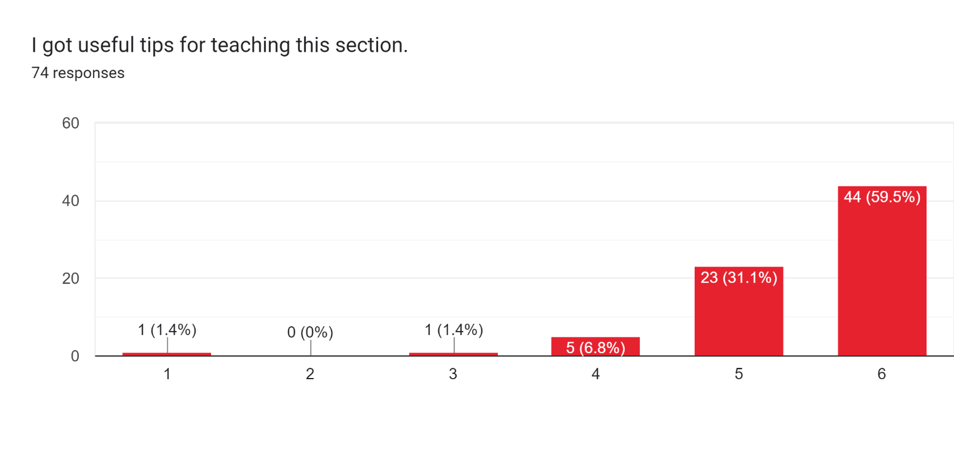
Any take-aways or additional comments regarding the webinar?
Haven’t taught it yet in my experienced years and the information was really helpful.
I'm starting with financial maths tomorrow - super motivated again!
The excels will be very useful - thank you!
Enjoyed the teaching strategies to teach Financial Maths
Very interesting especially showing the excel spread sheets
It shows me that I am on the right track regarding the Foundation I am lying in the gr 8 to 10 Groups.
Started with the basics and then gradually went deeper = this was stunning.
I liked part of percentages of capital VS interest
Love the excel tool
The introduction with percentages was very informative
Thanks to Paul for the additional resources mentioned. I loved the Excel applications!
It was wow so i will have to listen again as it so many real gems were shared.
Thank you, Gretel and Paul.
It was FANTASTIC- much appreciated
Excellent presentation thank you. Will implement some of new ideas with my learners, thank you.
Two days per topic
I love the part of using the spreadsheet and Bank loan calculators to integrate the teaching in class, and methods of calculating the outstanding balance.
I joined a little late but it was interesting to refresh on the different approaches of amortization . Will really appreciate the recording to find out on what I missed out
The recording will work to watch it again.
Loved the add on resources ie excel spreadsheet etc
Thanks for recording, need to go back to some of the last questions. Thanks for the extras
the number line with Pv and Fv to summaries how they work: Brilliantly simple!
Paul is clearly a master teacher who speaks well and explains clearly.
This was great, thank you. I've been teaching gr 8 - 12 maths since 1983 - and still benefit from this kind of interaction. It is also such a blessing from those of us who are far from the cities, to be able to attend webinars, instead of having to take time off teaching to travel to seminars.
Good alternative methods giving the same solutions.
Good presentation. Thank you
None
I wish he could have done questions where number of payments are given as dates. Though insignificant in the greater scheme of things. Will you be doing Grade 12 Probability this year
Curriculum needs to be revisited.
Interesting excel spreadsheet
It was an amazing presentation, with a lot of information. It is definitely worth a revisit.
Thanks very much for empowering me. Appreciate it.
Paul's enthusiasm is infectious.
I can't wait to go and revise with my learners and apply all the valuable skills I learnt today.
Methods of teaching different types of annuities especially differed payments and armotised loans. Calculations for outstanding balance were useful and appreciated
It was exceptional thanks a lot
I will definitely look for shayizibalo videos.
It was very helpful to deal with different methods for calculating multi-focal questions. It is also great that there is a video to go back for reference.
I am more confident now about teaching this topic (financial mathematics),thank you so much.
I enjoyed the integration of the topic to real life situations in the banking industry, making learners realize that what they learn in class is applicable in real life.

