€
₤

Show me the money!
The Mathematics of Finance



This workbook may be copied, altered and shared freely. It may not be sold.

www.shayaizibalo.com
$
R
Revision of prior, hopefully existing knowledge and skills! 😊

Given that percentage is such a central concept in Financial Maths, let’s quickly review the basics.

% - the SI unit of fractions!

Complete the following table:

Decimal | %
0,06
0,6
0,006
1,06
0,94
 | 8%
 | 80%
 | 0,9%
 | 108%
 | 92%
 | 500%

An efficient way of increasing or decreasing a number by a given percentage.

Suppose we wish to increase 700 by 6%

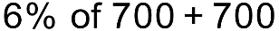
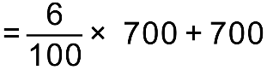
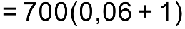
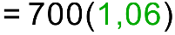
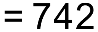

What if we wanted to increase 250 by 12%?

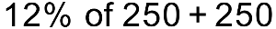
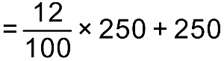
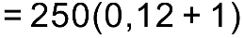
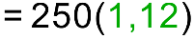
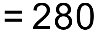

What if we wanted to increase 300 by 20%? We would simply multiply by 1,2

Notice that, in each case, our multiplier has been > 1 – we are increasing!

What about decreasing 600 by 10%?

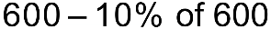
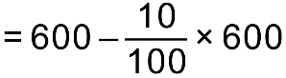
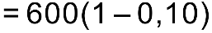
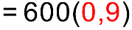
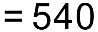

What if we wanted to decrease 300 by 20%?

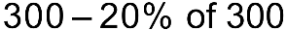
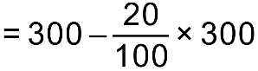
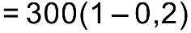
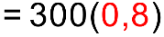
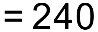

Decrease 90 by 6% Simply multiply it by 0,94

The price of a share drops by 20% and then increases by 20%. What is the net effect?

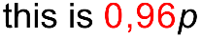
A net loss of 4%

Suppose an item costs R490 after a 20% discount has been offered. What did it cost before the discount was applied?

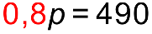
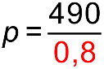
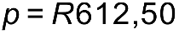

Suppose an item costs R102,35 with 15% VAT included. What did it cost before the VAT was added?

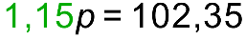
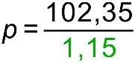
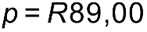

The price of a share drops by 10% and then increases by 20%. Would it matter if it increased first and then dropped?

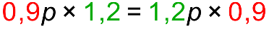

An item is discounted from R300 to R285. What percentage discount was applied?

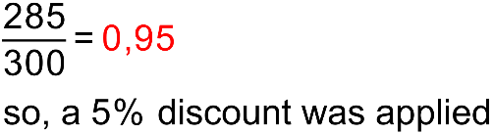

An item bought for R200 was sold for R475. What was the percentage profit?

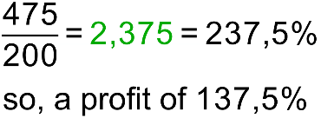

Explain why 17% of 57 is the same as 57% of 17!

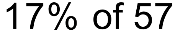
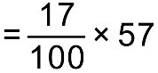
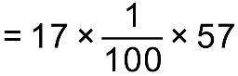
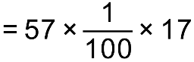
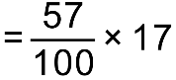
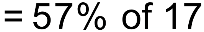

Understanding these multipliers will help us better understand the formulae involved in financial maths.

R300 is invested at 10% p.a. compounded annually. What will it be worth after five years?

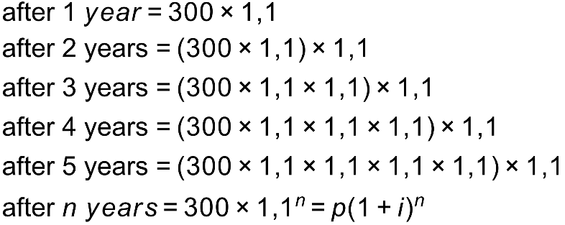
Now let’s review what we learnt before Grade 12!

In each of the formulae below:

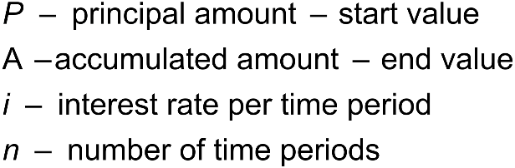

Appreciation occurs when something GAINS value 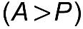
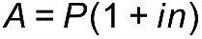 | simple increase / interest
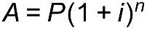 | compound increase / interest
Inflation is always calculated with the compound increase formula and is always compounded annually.

Depreciation occurs when something LOSES value 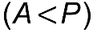

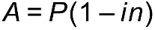 | simple decrease / straight line depreciation
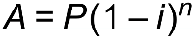 | Compound decrease / reducing balance depreciation
Reducing Balance depreciation is always calculated annually.

In maths when we are supplied all but one variable, we can solve for it.

Let’s do four examples, each one will use one of the above formulae and each will require us to solve for a different variable:

- I invest R100 at 12% per annum compounded annually. How much do I have at the end of five years?

- 3 years ago, I invested some money at 10% per annum simple interest. If I now have R520 then how much did I invest?

- An item depreciates from R500 to R200 according to the straight-line method. If this happened over 4 years, then what was the annual rate of depreciation?

- If my car depreciates by 15% per annum by the reducing balance method, then how long (to the nearest year) will it be before it is worth one-fifth of its original value?

The magical combination of time and compounding

Consider two individuals who start working on the same day. Each works for 30 years. Both invest money into an account paying 12% p.a. compounded monthly.

IM Clever invests R1000 per month for the first three years of her career and then leaves the investment in the account. | Miss Doubt waits for 10 years and then invests R1000 per month for the final 20 years of her career.
Ends with: R 1 082 354,01 | Ends with: R 989 255,37

Nominal and effective rates

12% p.a. compounded quarterly is called a NOMINAL rate.

It can be written in symbols as: 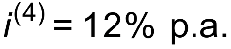 and it means that one will receive 12% interest over the year but one’s interest will be calculated FOUR times per year, 3% each time.

The net result over a year will be GREATER than 12% and is called the EFFECTIVE rate.

Effective rates are always GREATER than nominal rates!

Some people learn this formula, which is not provided:

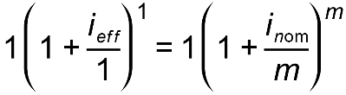

However, the easiest way to convert between nominal rates and effective rates is to consider investing R1 for 1 year. The only formula we need is which is provided.
Let’s consider three examples:

- Convert a rate of 10% p.a. compounded monthly to an effective annual rate

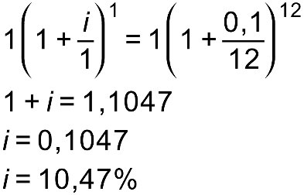

- What annual rate compounded quarterly will give the same return as an effective annual rate of 19%?

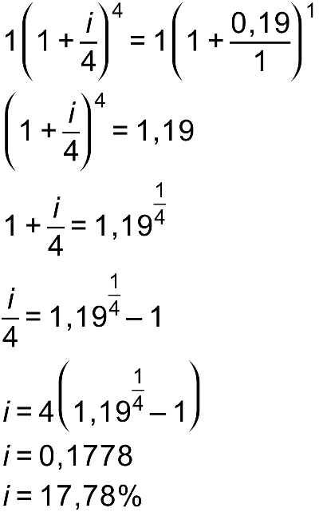

- Determine what annual rate compounded monthly will give the same return as 12% per annum compounded quarterly.

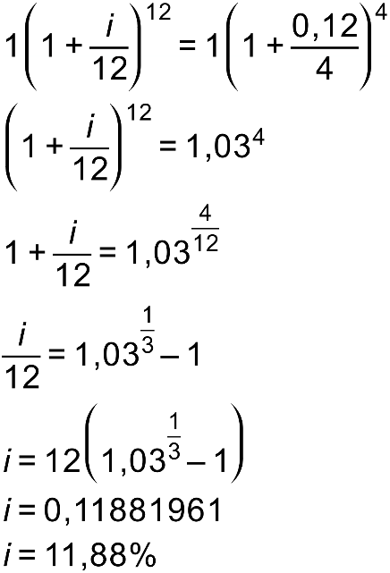

Timelines are useful when there are multiple withdrawals, deposits or changing interest rates.

Example 1

I deposit R5000. Three years later I withdraw R3000. How much will I have 7 years after my initial deposit if interest is paid at 12% per annum compounded monthly for the first two years and then at 16% per annum compounded quarterly thereafter?

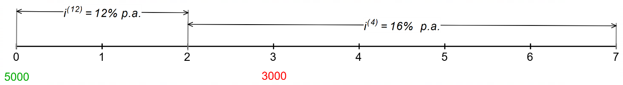

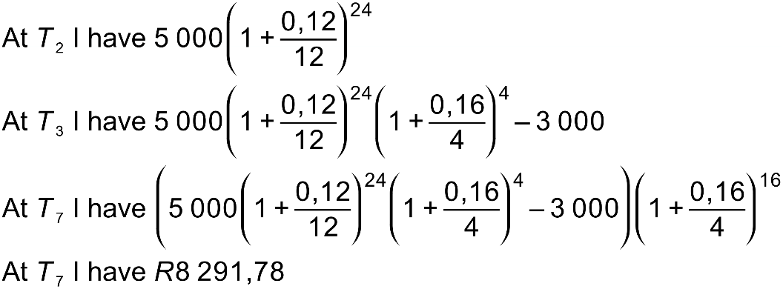

OR consider each “investment” in a separate account!

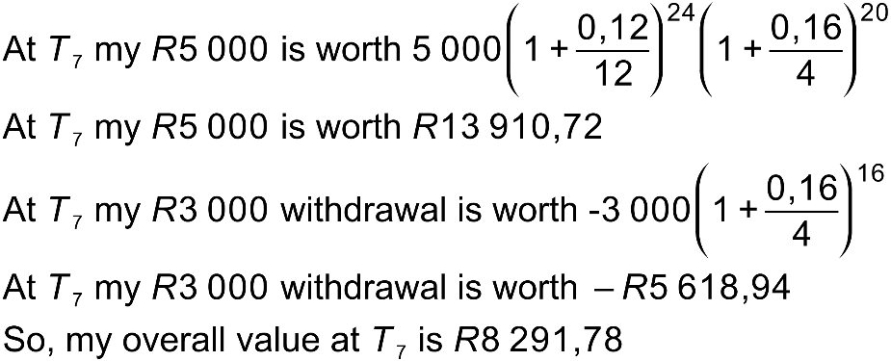
Example 2

Consider this example:

I deposit an amount of x. Three years later I deposit a further x and then a year after that I withdraw x. Interest is 10% p.a. compounded annually for the first two years and 12% p.a. compounded quarterly for the next three years. Find x if I end up with R10 000 after 5 years.

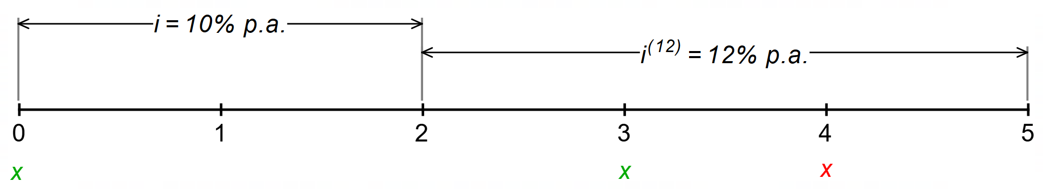

Method 1:

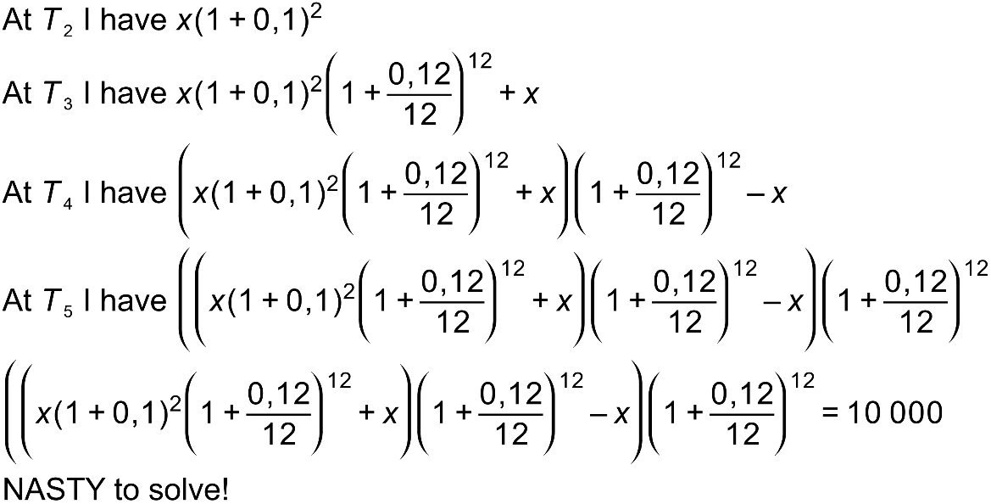

Method 2: Consider each “investment” separately – MUCH easier!

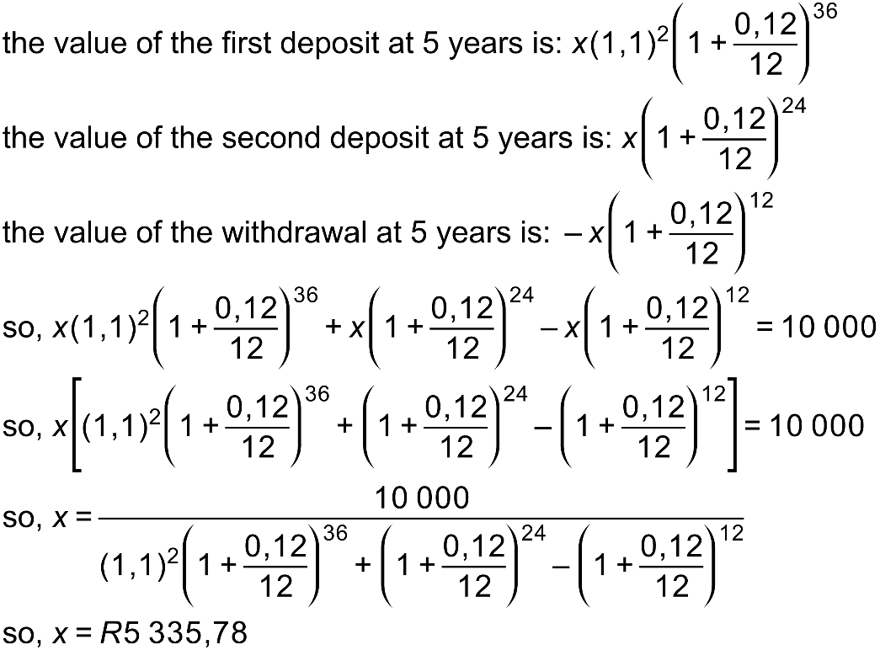

More practice

- I invest R300 into an account paying 18% per annum compounded monthly. How much will I have after 5 years?

- An item depreciates according to the reducing balance method in such a way that it loses 60% of its value in 5 years. What is the annual rate of depreciation?

- If inflation is 6% per annum then determine how long it will take for a loaf of bread which currently costs R11 to cost R20? Give your answer to the nearest year.

- How much must I invest today in order to have R5000 in 6 years’ time if interest is paid at 12% per annum compounded monthly for the first 4 years and then at 16% compounded quarterly for the next two years?

- Convert a rate of 16% per annum compounded monthly to an effective annual rate.

- What annual rate compounded quarterly will be equivalent to an effective annual rate of 14%?

- What annual rate compounded monthly will be equivalent to a rate of 20% per annum compounded quarterly.

- A man deposits x. Three years later he withdraws x and two years after that he deposits a further x. Seven years after the date of his initial deposit he has R6000. Find x if interest was 17% per annum for the first three years and then 16% per annum compounded quarterly for the next four years.

Annuities

An ANNUITY is a series of equal, regular payments for the purposes of saving (a future value annuity) or repaying a loan (a present value annuity).

Let’s look at a future value annuity first:

Mr Khumalo deposits R300 per month for 10 years into an account which pays interest at 12% per annum compounded monthly.

Note that with annuities, the interest is always compounded with the same frequency as the payments are made.

How much does he have immediately after making his final payment?
Pmt. 120
Pmt. 119
Pmt. 118
Pmt. 4
Pmt. 3
Pmt. 2
Pmt. 1

R300
R300
R300
R300
R300
R300
R300

Using the formula and working from the back:

Mr Khumalo will have:

This is a geometric series with 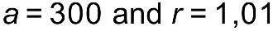

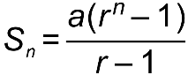

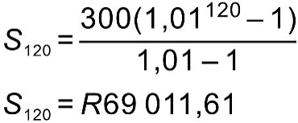

How much interest did he earn?

IMPORTANT IDEA!

The interest earned is simply the difference between the total amount and the sum of all the contributions.

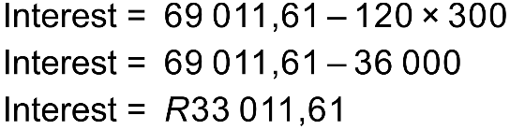
Let’s generalize this to create a formula!

Suppose we invest x per interval for n intervals and interest is paid at i% per compounding interval. How much will we have immediately after making our last payment?

Pmt. n – 1
Pmt. 4
Pmt. 3
Pmt. 2
Pmt. 1
Pmt. n – 2
Pmt. n

x
x
x
x
x
x
x

Using the formula and working from the back:

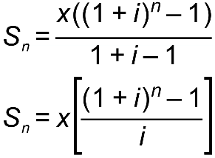

Note that this is called the FUTURE VALUE formula. It gives us the FUTURE VALUE of n equal payments of x with interest at i% per compounding period. It gives us the balance immediately after the last payment is made. In other words, the last payment does not earn any interest.
Here it is, as supplied on the IEB Formula sheet.

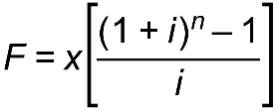

Let’s use it to solve a couple of problems!

- I wish to raise R25 000 over a 7-year period making monthly payments. How much must I invest each month if interest is paid at 14% per annum compounded monthly?

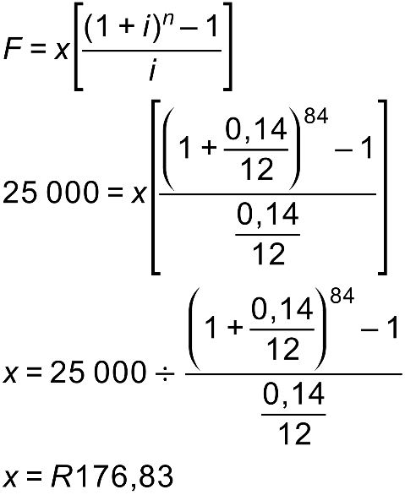

- How long (to the nearest quarter) will it take me to raise R60 000 if I make quarterly payments of R800 and interest is paid at 12% per annum compounded quarterly?

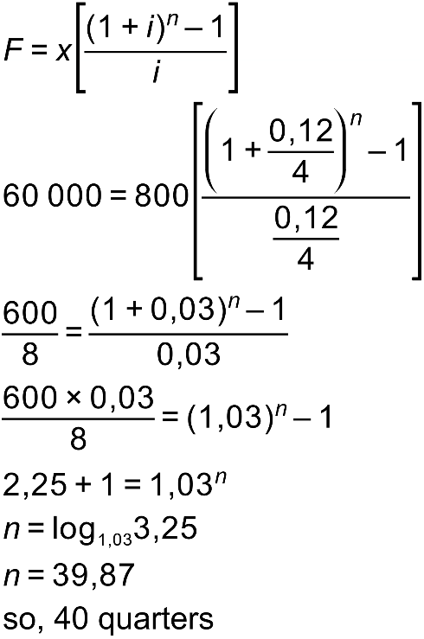

- I make monthly payments of R500 for 10 years. How much will I have three months after making my last payment if interest is paid at 12% per annum compounded monthly? How much interest do I end up earning?

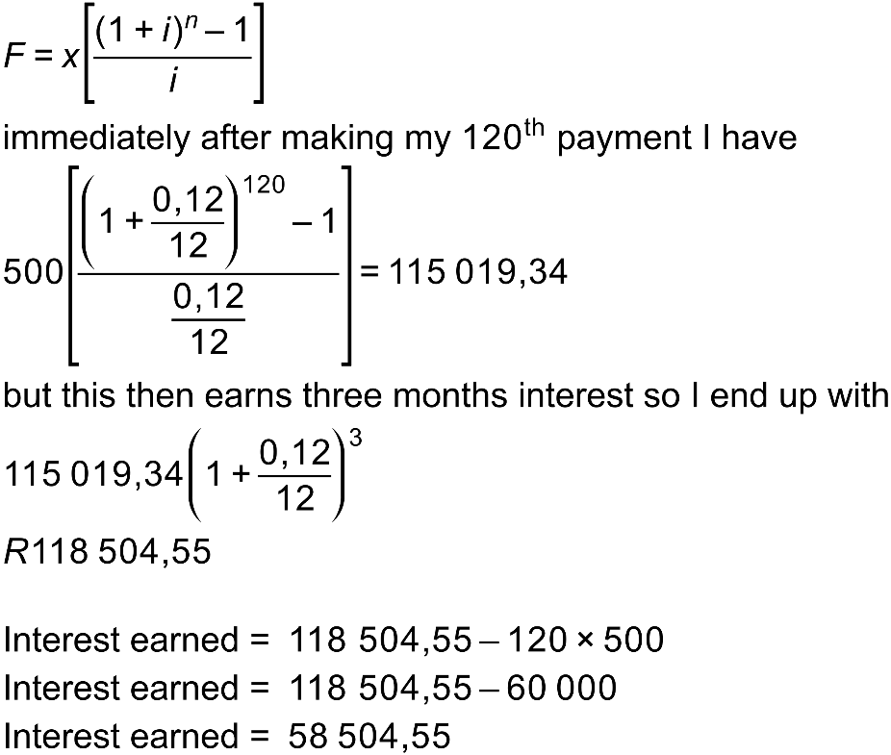

More practice on Future Value Annuities

- I invest R300 per month for 5 years. If interest is paid at 9% per annum compounded monthly, then how much will I have in the account immediately after making my final payment?

- How much should I invest each month if I wish to raise a sum of R10 000 in 2 years and interest is paid at 12% per annum compounded monthly.

- How long (in months) will it take to raise R303 333.00 with monthly payments of R4000 if interest is paid at 10% per annum compounded monthly. Give your answer to the nearest month.

- How much interest was earned in question 3?

Sinking fund

A sinking fund is a SAVINGS fund which is typically set up for the replacement of equipment.
A sinking fund is typically set up to meet the shortfall between the inflated price of a replacement item and the depreciated value of the item due to be replaced.
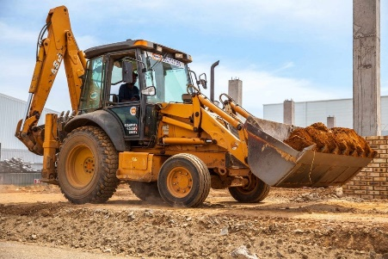
As always, let’s look at an example:

Skulule’s Construction® has recently bought a TLB (tractor, loader, backhoe) as shown.

It cost R850 000.

Skulule anticipates the following:

- It will depreciate at 10% per annum according to the reducing balance method.
- He will get 7 years’ worth of use from it after which he will be able to sell it at its depreciated value.
- The price of a new TLB is expected to increase due to inflation at an average of 7% p.a.

- What will Skulule’s TLB be worth in 7 years’ time?

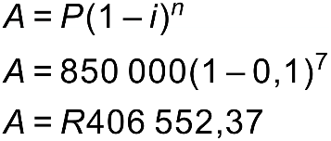

- What will a replacement cost?

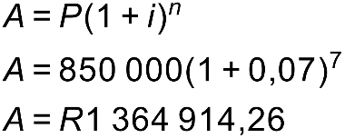

- How much money will Skulule be short of replacing his TLB in 7 years’ time?

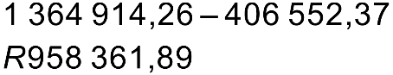

- How much should Skulule’s Construction® put aside each month in a sinking fund in order to be able to replace the TLB. He is able to secure an interest rate of 9% p.a. compounded monthly.
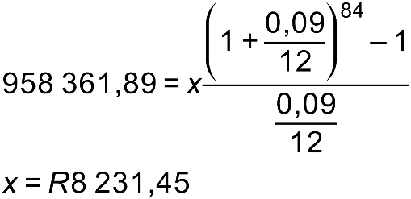
Present value annuities

Before we dive into present value annuities, let’s talk about the time-value of money.

Would you rather have R500 now or in a year’s time?

Definitely now! If I invest it now I will have more than R500 in a year’s time!
Alternatively, if I spend it on chocolate now I will get more chocolate now than in a year's time!

The reality is that money has a value which is dependent on when in time it exists. That is why we cannot simply add deposits made at different times on a timeline.

Now, bearing this in mind……

Suppose I want to borrow some money from you today. I will repay you R100 per year for 5 years, starting one year from now. How much can I borrow if you are going to charge me interest of 12% p.a. compounded annually?

So, I am going to pay you a total of 5 payments of R100 but each is worth a different amount in today’s terms.

Remember that
is the formula which puts interest onto an amount. So, the formula which removes interest is 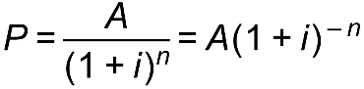.
In this case interest is at 12% per annum, compounded annually.

So, we need to work out the value of each of these future payments in today’s terms

In today’s terms the first payment is worth: 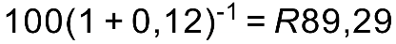

In today’s terms the second payment is only worth: 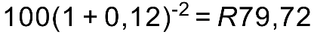

In today’s terms the third payment is only worth: 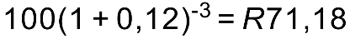

In today’s terms the fourth payment is only worth: 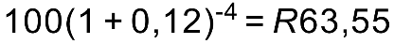

In today’s terms the fifth payment is only worth: 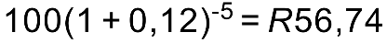

The total value of the payments in today’s terms is: 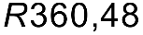

This is how much I can borrow today with these repayment terms.

Now, let’s generalize this……..

Suppose I make n regular payments of x with interest of i% per time period, compounded each time period with my payments starting one period from today.

The total value of the payments in today’s terms is:

This is just a geometric series with:

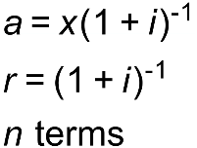

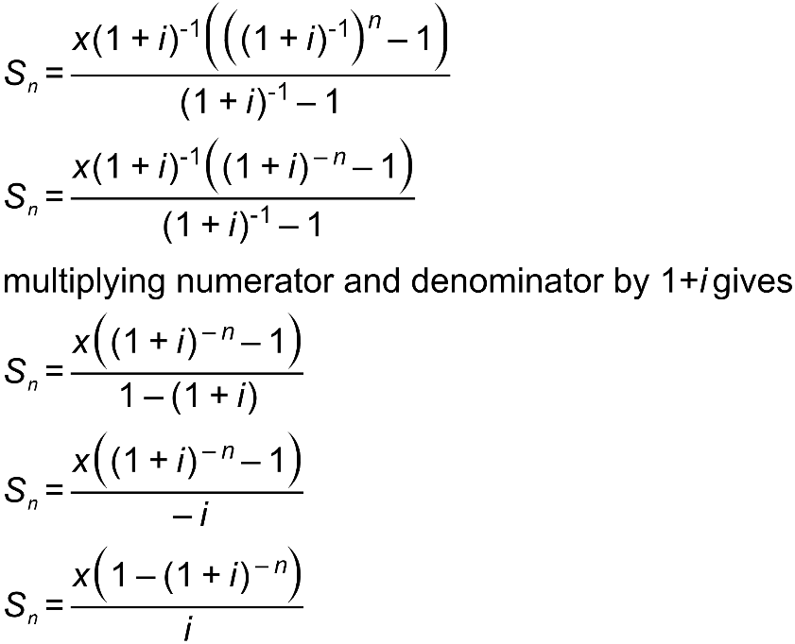

Note that this is called the PRESENT VALUE formula. It gives us the PRESENT VALUE of n equal payments of x with interest at i% per compounding period. It assumes that the first payment is made one payment period from today.
Here it is, as supplied on the IEB Formula sheet.

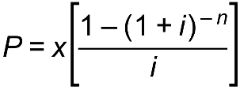

Let’s use it to solve a couple of problems

I borrow R1 500 000 and agree to pay it back over 20 years with equal monthly payments starting one month from the date of the loan. Interest is charged at 11,5% per annum compounded monthly. How much is my monthly payment?

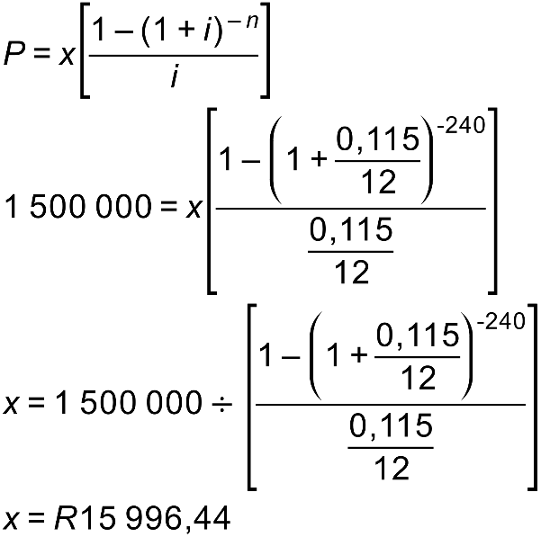

Let’s model this on a spreadsheet……

Let’s look at https://www.absa.co.za/personal/loans/for-a-home/calculate/

How much interest do I end up paying?

An important idea:

The total interest paid is the difference between the sum of all the payments and the amount borrowed.

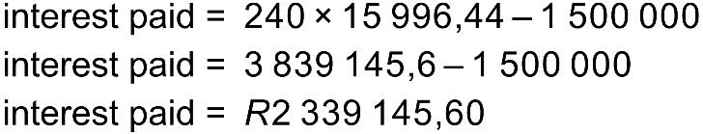

Now let’s look at another example:

I borrow R200 000 and repay it with monthly payments of R2000 starting 8 months from the date of the loan. If interest is at 9% per annum compounded monthly, then how many payments must I make. Give the total number of payments even though the last one will be less than R2000.

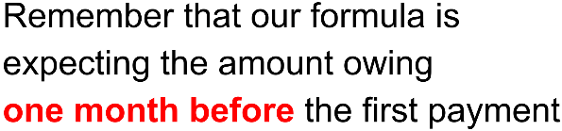

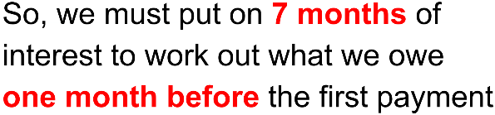

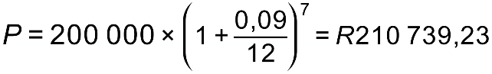

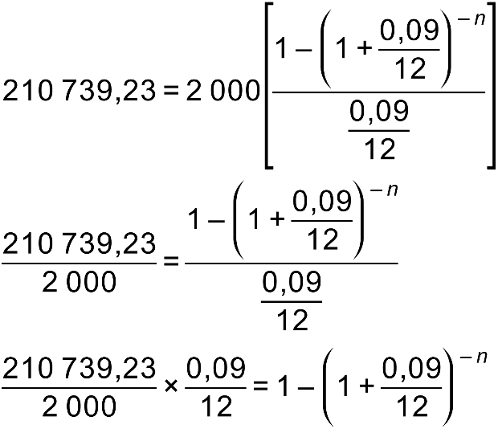

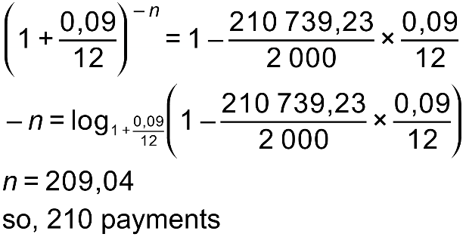

The above example is called a deferred annuity

The reality is that individuals often do not start repaying a loan immediately. This can be for any number of reasons, including:

Marketing!

“Get your new car before Christmas and only make your first repayment in March”.

However, often it is more legitimate than that. Suppose one borrows money from the bank to start a business. It may take one some time to get going, to hire premises, buy equipment, hire employees etc. etc. It might well be the case that it is a while before any money comes in and one is able to repay the loan.

As always, let’s consider an example:

Mayenziwe borrows R100 000 to start a business. He repays it with 60 equal monthly payments but only starting 9 months from the date of the loan. Interest is charged at 10% per annum compounded monthly.

What is his monthly repayment?

How much interest does he end up paying altogether?

So, let’s summarise this….

If the first repayment on a loan is only made in 9 interval’s time then we must first put on 8 periods of interest in order to work out how much is owing one interval before our first payment as this is what the formula “expects”.

Why don’t you try one?

Tom borrows R20 000 and repays it with 12 equal quarterly payments starting one year from the date of the loan. Interest is charged at 16% per annum compounded quarterly.

Calculate his quarterly repayment

Let’s finish off with one last example:

Bongani wishes to buy the house shown:

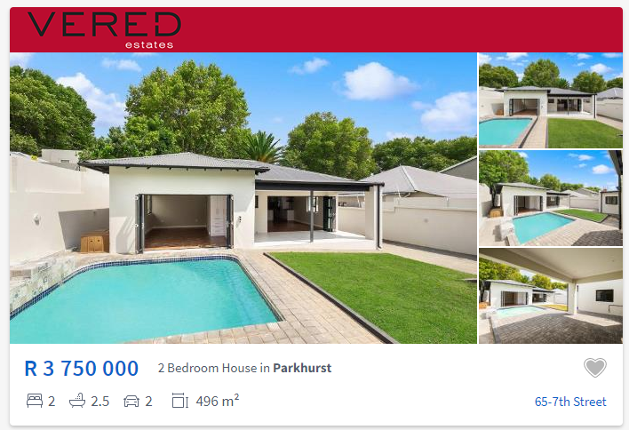

Suppose that he has R750 000 to put down as a deposit. He borrows the balance from ABSA who charge him 10% per annum, compounded monthly. He repays it over 20 years with monthly payments starting a month from the date of the loan. What is his monthly repayment?

So, in summary:

We have two types of annuity:

Future Value | Present Value
For saving / investing | For repaying a debt
The formula gives the future value of all the payments immediately after the last payment has been made | The formula gives the present value of all the payments given that the first payment is made in one period from now

With both, the payments are made in the future but with a future value annuity, we are interested in the value of the payments in the future. Such annuities apply to savings. With a present value annuity, we are interested in the value of the payments today.

It is vital to remember out what each formula gives us:

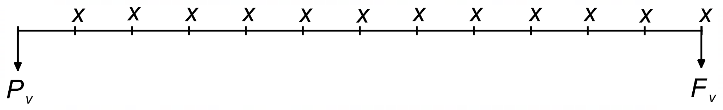

More practice on Present Value Annuities

- I borrow R30 000 and repay it with quarterly payments over 5 years starting one quarter from the date of the loan. If interest is charged at 16% p.a. compounded quarterly, then how much is my quarterly repayment?

- I am able to afford a monthly repayment of R700 per month for 5 years. If interest is charged at 9% per annum compounded monthly, then how much can I borrow?

More on loans

It is important that we fully understand the way a loan works. Loans are often called mortgages and we are sometimes asked to draw up an amortization schedule. Both these words contain the French word mort which means death. By making our payments we kill off the loan!

Suppose I borrow R20 000 with interest charged at 15% per annum compounded annually. I repay it over 4 years.

Complete the following Amortisation Schedule. First, we need to work out the monthly payment. It is R7 005,31

Pmt No. | Interest charged | Outstanding balance immediately before this payment | Annual payment | Proportion of payment going to interest. | Proportion of payment going to capital. | Outstanding balance immediately after this payment.
1
2
3
4

When a loan is repaid, each payment pays the interest charged on the outstanding balance after the previous payment has been made.

So, for example, after the 6th payment is made there is still an amount owing. One month of interest is then added to this amount. The 7th payment then pays this interest while also reducing the value of the loan (capital)

Any payment is split between paying capital and paying interest. The interest is always calculated on the amount still owing so, while the payment stays the same, the proportion of the payment going to interest gradually reduces while the complement (the balance) increases – this is the proportion going to reducing capital.

This is nicely illustrated in the following graph:

How to save nearly a million rand!
By paying in extra on a bond we reduce the total interest charged as the extra contribution goes directly to reducing the CAPITAL (the amount owing)

Consider the home loan example….

When the exact minimum monthly payment of R15 996,44 was made we had:

However, if we increase our monthly payment to R18 000 then we only need 168 payments and now

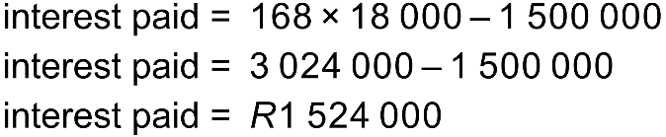



We need to be able to calculate how a given payment (or a range of payments) is split between interest and capital. Before we can do this, we need to be able to calculate the OUTSTANDING BALANCE at any given stage of a loan. This is the amount that is outstanding at any given time.

There are two ways of working out an outstanding balance.

Either

Method 1

Calculate the value of the loan plus interest less the value of all the payments that have been made plus interest (a future value annuity)

OR

Method 2

Calculate the present value of all the outstanding payments (those that have not been made). Unfortunately, this simpler method only works when we know the total number of payments and the required payment is being met exactly. If extra is being paid or if we don’t know the number of payments up front we must use method 1. Method 1 always works and it is therefore favoured by most teachers.

Let’s consider an example:

James borrows R100 000 in order to buy a car. He repays it with equal monthly payments over 5 years, starting one month from the date of the loan. Interest is charged at 12% p.a. compounded monthly. We can show that his monthly repayment is R2 2244,44.

How much does he owe immediately after making his 25th payment?

METHOD 1

Calculate the value of the loan plus interest less the value of all the payments that have been made plus interest (a future value annuity)

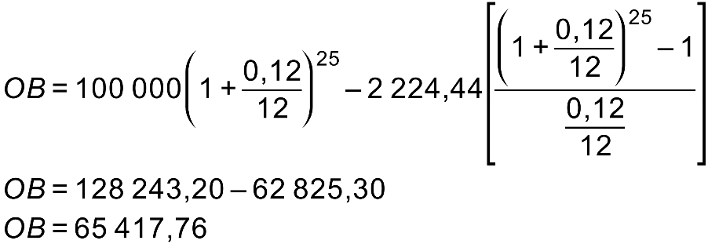

METHOD 2

Calculate the present value of all the outstanding payments (those that have not been made) – in this case 35)

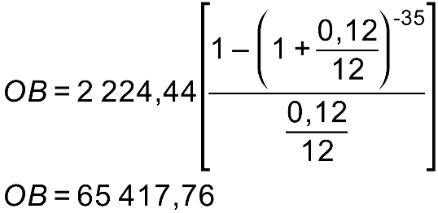

Cindy borrows R100 000 in order to buy a car. He repays it with monthly payments of R3 000 starting one month from the date of the loan. Interest is charged at 12% p.a. compounded monthly.
How much does he owe immediately after making her 20th payment?

NOTE: method 2 will not work here!
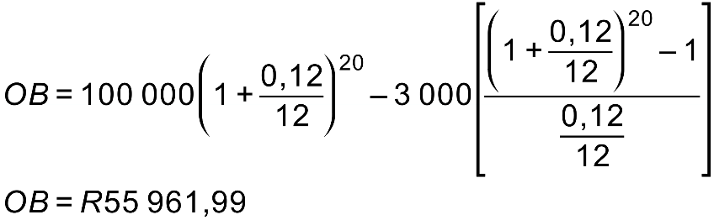

Let’s consider one more example:
I borrow R30 000 with interest charged at 10% per annum compounded monthly. I repay it with monthly payments of R700. How much will I still owe immediately after making my 20th payment?

More practice on outstanding balance

- Ayabonga borrows R20 000 from a friend who charges him 7% p.a. compounded monthly. He repays it with monthly payments of R500 starting one month from the date of the loan. After making 18 payments he wins some money on the Lottery and decides to settle the loan. How much does he still owe his friend at this time? Note: method 2 will not work here!

- Joshua borrows R10 000 from his Mum in order to start a T-shirt printing business. She charges him 10% per annum compounded monthly. He pays it back monthly over 3 years starting one month from the date of the loan.

  - What is his monthly repayment?

  - Calculate the amount he still owes his Mum immediately after making his 14th payment. Calculate it using both methods:

Method 1 | Method 2

Calculating the contributions of loan repayments

When a loan is repaid, each payment pays the interest charged on the outstanding balance after the previous payment was made.

Let’s look at an example.

Lazola borrows R30 000 and repays it over 4 years with monthly payments starting one month from the date of the loan. Interest is charged at 18% p.a. compounded monthly.

- Calculate his monthly repayment

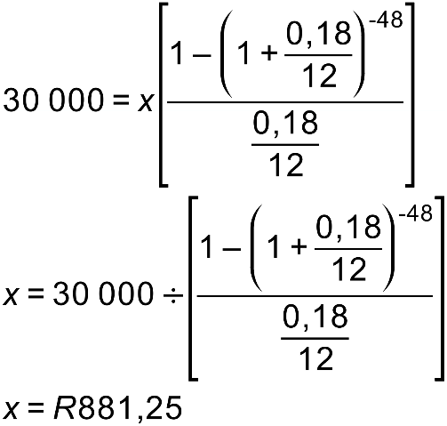

- Calculate how his 36th payment is split between interest and capital.

So, we need to know his outstanding balance immediately after his 35th payment

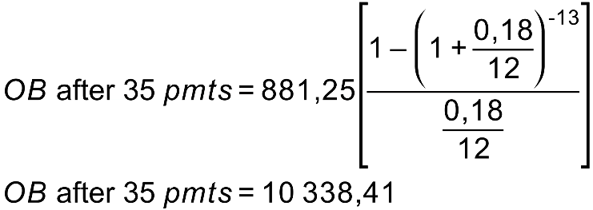

Now, after making his 35th payment the bank charges one month of interest.

This is 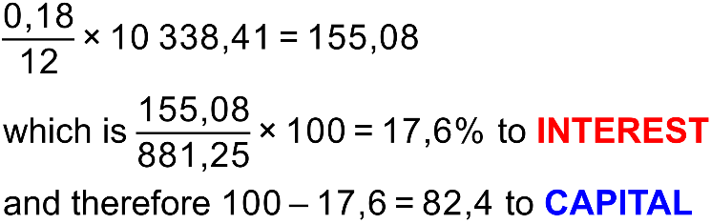

Oliver borrows R2 000 000 to buy a house. The bank charges interest at 9% per annum compounded monthly. Oliver works out that he can afford to repay R20 000 per month, starting one month from the date of the loan. How is his 12th payment split between interest and capital?

This method works really well when we want the (INTEREST / CAPITAL) split for a single payment.

However, sometimes we want the split between a range of payments.

Here we make use of this simple but important idea:

Suppose we know the outstanding balance at two points in time – let’s call them OB1 and OB2

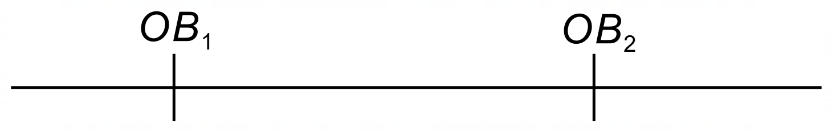

The difference between them OB₁ – OB₂ is CAPITAL

We can work it out as a percentage of the total of all the repayments made between these times.
This will be the percentage of those payments which went to CAPITAL
The complement will be the percentage of those payments which went to INTEREST

Let’s try an example:

Kabelo borrows R200 000 from the bank. He repays it with quarterly repayments over 5 years, making his first payment one quarter from the date of the loan. Interest at 12% per annum compounded quarterly.

What percentage of his payments in the second year goes to capital? To interest?

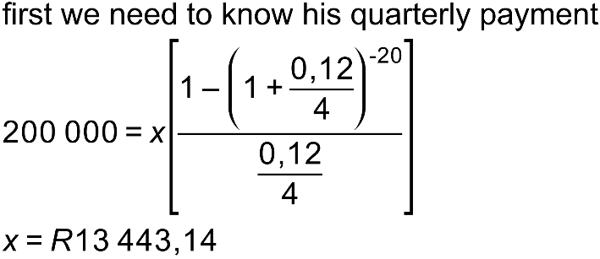

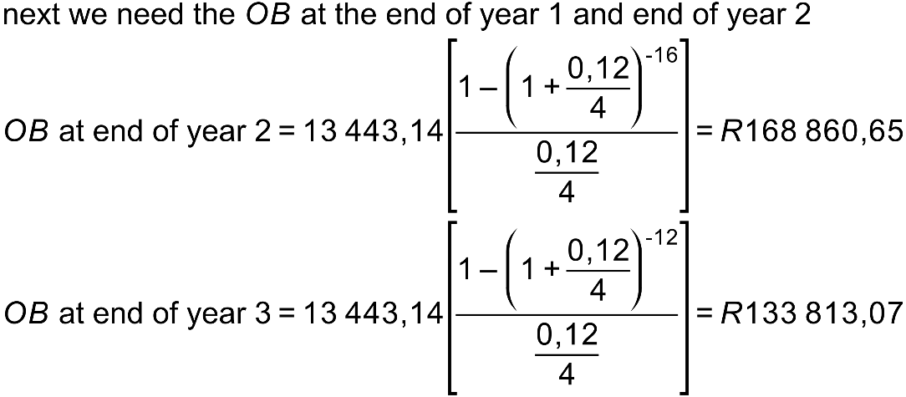

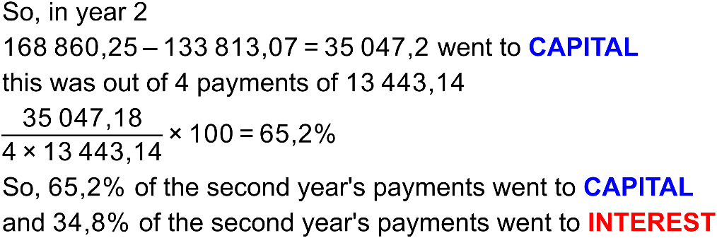

Once again, you try one!

Tom borrows R1 000 000 to buy a house. He repays it with monthly payments starting one month from the date of the loan. He repays it over 20 years with interest of 10% p.a. compounded monthly. His monthly repayment works out to exactly R9650.22

What percentage of his first year’s payments go to interest?

More practice on calculating contributions of payments

- Mr Coxon borrows R200 000 to buy a car. He repays it over 54 months with interest charged at 9% per annum compounded monthly, starting one month from the date of the loan.

  - What is his monthly repayment?

  - What proportion, expressed as a percentage, of his 13th payment goes to capital?

  - What proportion, expressed as a percentage, of his second year’s payments (from the 13th to the 24th inclusive) goes to interest?

Calculating a last, lesser payment

Often when people repay a loan, they work out what they can afford to pay. This then results in a non-whole number of payments. We have already encountered this, but we sidestepped it by simply rounding our answer to the nearest month.

As mathematicians we love accuracy so let’s look at calculating the last, lesser payment.

Let’s do so by means of an example:

Sihle borrows R40 000 with interest charged at 9% per annum compounded monthly. He repays R900 per month starting one month from the date of the loan.

How many payments does he make?

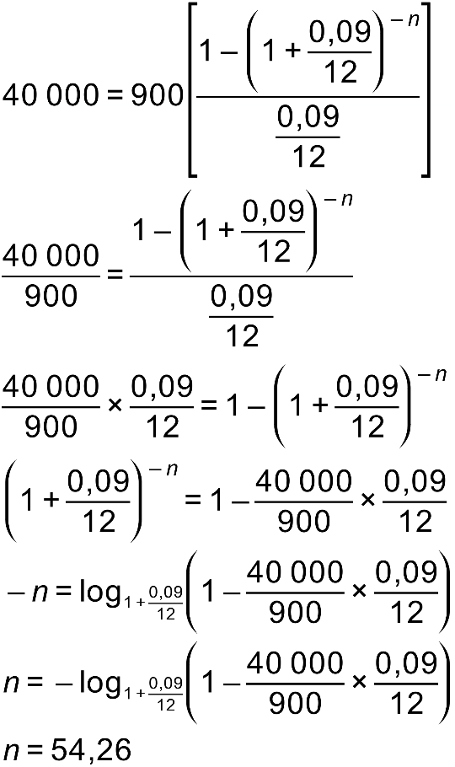

So, he makes 54 payments of R900 and one last, lesser payment.

Let’s work out how much it is in two different ways!

Method 1 | Method 2
Remember that the present value of all of the payments must equal the value of the loan. Let’s let the last payment be x  Remember  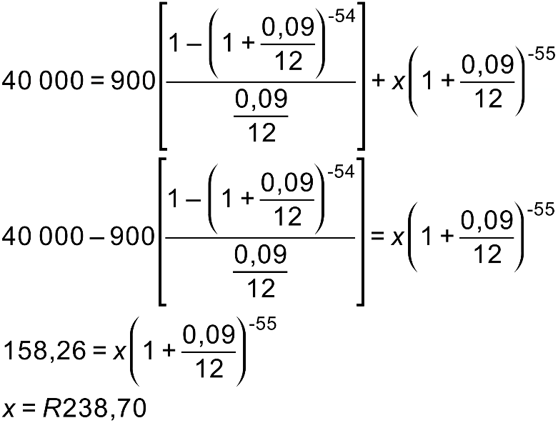 | Calculate the outstanding balance after 54  payments and add one month of interest!  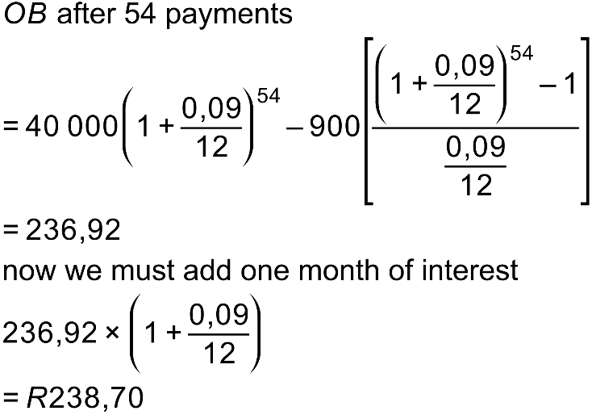

Why don’t you try one?

Robbie borrows R50 000. He repays it with monthly payments of R1000 starting one month from the date of the loan. If interest is charged at 12% per annum compounded monthly, then how many payments must he make and what is the value of his last, lesser payment?

Method 1 Method 2

Remember that the present value of Calculate the outstanding balance after ____
all of the payments must equal the value payments and add one month of interest!
of the loan. Let’s let the last payment be
x

Remember

More practice on deferred annuities and last, lesser payments

- Mr Laing borrows R100 000 to buy a car. He repays it over 48 months with interest charged at 10% per annum compounded monthly, starting four months from the date of the loan.

  - What is his monthly repayment?

  - How much interest does he end up paying?

- Ms Moffat borrows R100 000 from her father to go on an overseas holiday. She repays R900 per month starting one month from the date of the loan. If interest is at 6% per annum compounded monthly then how many payments must she make and what will be the value of her last, lesser payment?

A final question involving both annuity types!

A man invests R5000 per month for 25 years into an account paying 10% p.a. compounded monthly. Thereafter he retires. If he plans to live for 15 years. How much can he withdraw each month if his money now earns interest at 8% p.a. compounded monthly? You can assume he wishes to die penniless!

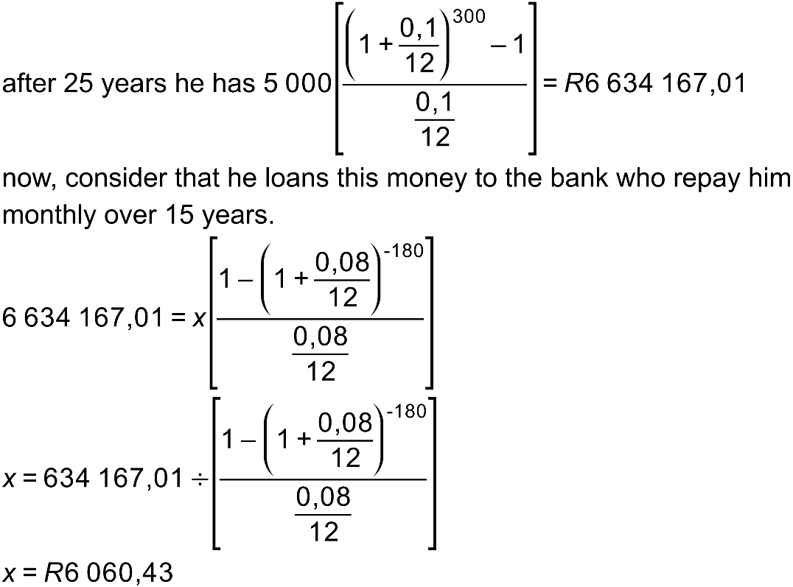

A question involving the extension of a bond

A lady buys a house costing R2 000 000. She takes a bond over 20 years and makes monthly repayments starting one month from the date of the loan. Interest is charged at 11% p.a. compounded monthly. After 5 years she decides to put in a swimming pool costing R170 000 and she borrows this money from the bank without extending the duration of the loan. How much extra does she need to pay per month?

- Calculate the monthly payment
- Work out the outstanding balance after 60 months
- Add R170 000
- Work out the monthly payment on a new loan over 180 months
- Find the difference between the two payments

The dilemma of compound interest

Suppose my money is being compounded annually. If I visit the bank after 364 days I will receive no interest. This hardly seems fair.

We know that compounding more often is more beneficial. So, what do banks do?

Consider R1 invested for 1 year at 100% interest but with different compounding periods:

Compounded | Final amount
annually | R2,000000000
semi-annually | R2,250000000
monthly | R2,613035290
weekly | R2,692596954
daily | R2,714567482
hourly | R2,718126692
every minute | R2,718279243
every second | R2,718281781
every millisecond | R2,718277881

The amount approaches a limit of e – like pi, it is a famous irrational constant.

The formula for continuous compound increase is

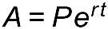

So, for example, if R1000 is invested for 6 years at 12% p.a. compounded continuously

We end up with

